Project Design Phase
Solution Architecture

Date | 25 February 2026
Team ID | LTVIP2026TMIDS78743
Project Name | Cafeteria Menu Display Main
Maximum Marks | 4 Marks

Solution Architecture:
A solution architecture for a ServiceNow-based Cafeteria Menu Display project focuses on digitizing menu management, automating updates, and providing a modern, visual display interface for employees. This leverages ServiceNow's platform capabilities to bridge backend catering operations with frontend digital signage.
Solution Architecture Diagram:
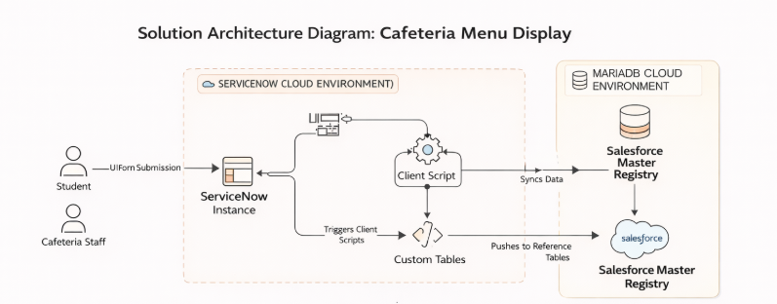
The architecture bridges the business problem of manual paper menus by using a 3-tier web structure. Data submitted via admin panel forms is processed by backend API endpoints and synchronized with a MySQL database for real-time display updates.
Component | Technical Role
User Interface | ServiceNow Service Portal for desktop/mobile and Digital Signage Screen for web-enabled TV/display
Application Layer | Custom Scoped Application ("Cafeteria Management") hosting all business logic and menu management functionality
Data Layer | ServiceNow tables including u_menu_items, u_daily_menu, and u_cafe_location for persistent data storage
Integration Layer | REST API for external vendor data integration or Scheduled Data Imports for CSV/Excel-based menu updates
Workflow Layer | Flow Designer for automated publishing of weekly and daily menus at scheduled times

